Identification of muller cells
Immunofluorescence Staining for Glutamine synthetase
(1) Cell Seeding on Coverslips
Place 3 glass coverslips into a 24-well plate. Add 1 mL of culture medium per well and seed cells at a density of 0.02 million cells per well. Incubate in a cell culture incubator for 2 hours or overnight.
(2) Fixation
After cell adherence, aspirate the culture medium and wash once with PBS. Fix cells with 4% PFA at 4°C for 30 minutes. Wash with PBS for 3 times, 5 minutes each. Alternatively, the final PBS wash may be retained and stored at 4°C overnight.
(3) Permeabilization and Blocking
Remove excess moisture from the coverslips and place them on supports in a petri dish. Blocking buffer preparation: Mix 0.5% Triton X-100 with PBS at a 1:1 ratio, then add 10% serum. Apply 50 µL of permeabilization/blocking buffer onto a hydrophobic membrane, and place the coverslip with the cell-facing side down for 2 hours.
(4) Primary Antibody Incubation
Primary antibody preparation: Dilute antibody in PBS at 1:100 (or 1:200).
After permeabilization and blocking, apply 50 µL of primary antibody onto a hydrophobic membrane (in a humidified chamber), place the coverslip with the cell-facing side down, and incubate at 4°C (can be stored for up to one week).
(5) Secondary Antibody Incubation
Incubate with secondary antibody (secondary antibody:PBS = 1:500) at room temperature in the dark for 2 hours. Wash with PBS for 3 times, 5 minutes each. Stain with DAPI (DAPI:PBS = 1:1000) for 5 minutes, then wash with PBS for 3 times, 5 minutes each.
(6) Mounting Apply 1 drop of Fluoromount-G onto the slide and mount the coverslip with the cell-facing side down.

Glutamine synthetase staining

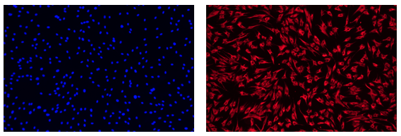
100X-DAPI 100X-Fluorescence
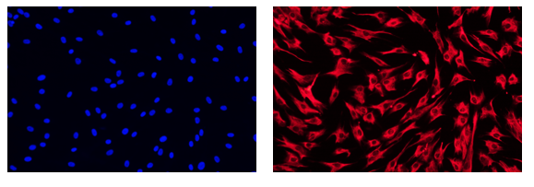
200X-DAPI 200X-Fluorescence

